

**University Institute of Information Technology,**

**PMAS-Arid Agriculture University,**

**Rawalpindi Pakistan**

**Project Name**

***By***

**Sheharyar Kalim 17-ARID-1574**

**Natalia Nisar 17-ARID-1557**

**Faizan Khan 17-ARID-1466**

***Supervisor*Mr Zeeshan Javaid**

***Bachelor of Science in Computer Science (20xx-20xx)***

***OR Information Technology OR Software Engineering***

**The candidate confirms that the work submitted is their own and appropriate  
 credit has been given where reference has been made to the work of others**.

**DECLARATION**

We hereby declare that this software, neither whole nor as a part has been copied out from any source. It is further declared that we have developed this software documentation and accompanied report entirely on the basis of our personal efforts. If any part of this project is proved to be copied out from any source or found to be reproduction of some other. We will stand by the consequences. No Portion of the work presented has been submitted of any application for any other degree or qualification of this or any other university or institute of learning.

Student Name 1 Student Name 2 Student Name 3

Sheharyar Kalim Natalia Nisar Faizan Khan

**CERTIFICATE OF APPROVAL**

It is to certify that the final year project of BS (CS/IT/SE) “Deep Learning based Chatbots” was developed by “**Natalia Nisar 17-ARID-1557”**, “Sheharyar Kalim 17-ARID-1574**”** and “**Faizan Khan 17-ARID-1466”** under the supervision of “Supervisor Name” and that in their opinion; it is fully adequate, in scope and quality for the degree of Bachelors of Science in Computer Science/Information Technology/Software Engineering.

Sir Zeeshan Javid

---------------------------------------

**Supervisor**

Maria Iqbal

----------------------------------------

**External Examiner (If any)**

---------------------------------------

**Administrator UIIT**

**Executive Summary**

In public places, there is often a need for monitoring people and different activities going on, which can be referred later for many reasons including security. Appointing humans for this task involves many problems such as increased employee hiring, accuracy problem, trust, no proof for later use, and also the fact that a human can remember things till a certain time limit. Talking about the current security system, they use dumb still cameras with a continuous recording facility ir-respective of the fact that any event may happen or not. Moreover they are usually pointing at a specific user defined locations so more than one cameras are required to cover the entire region.

To prevent all these problems from prevailing, the CSCS is developed. It is a surveillance system, which provides solution to many of these problems. It is a stand-alone application which doesn’t require any computer to operate. It monitors different situations using a camera which is able to rotate intelligently based on sensor messages and captures the scene in the form of video or photos later reference as well.

**C**ustomizable **S**urveillance **C**ontrol **S**ystem **(CSCS)** is a surveillance system that can be assigned a sensor type as in our case a heat sensor is used, it works accordingly, rotates the camera upon event detection and perform user defined actions like capturing video and stores them, for the future use.

It is an embedded system consisting of Linux fox kit with embedded a running server application also a camera, USB storage device and a sensor node base station is attached with fox kit. LAN communication is used by user to download the videos and to operate the system manually.

**Acknowledgement**

All praise is to Almighty Allah who bestowed upon us a minute portion of His boundless knowledge by virtue of which we were able to accomplish this challenging task.

We are greatly indebted to our project supervisor “Sir Zeeshan Javaid” and our Co-Supervisor “Dr. Tariq Ali” for personal supervision, advice, valuable guidance and completion of this project. We are deeply indebted to him/her/them for encouragement and continual help during this work.

And we are also thankful to our parents and family who have been a constant source of encouragement for us and brought us the values of honesty & hard work.

Student Name 1 Student Name 2 Student Name 3

Sheharyar Kalim Natalia Nisar Faizan Khan

**Abbreviations**

|  |  |
| --- | --- |
| **SRS** | Software Requirement Specification |
| **PC** | Personal Computer |
|  |  |
|  |  |
|  |  |

**Table of Contents**

**Introduction 1**

1.1 Brief 2

1.2 Relevance to Course Modules 2

1.3 Project Background 3

1.4 Literature Review 3

1.5 Methodology and Software Life Cycle 5

**Problem Definition** 6

2.1 Purpose 7

2.2 Product Functions 7

2.3 Proposed Architecture 7

2.4 Project Deliverables 8

2.5 Operating Environment 8

2.6 Assumptions and Dependencies 8

**Requirement Analysis** 9

3.1 Functional Requirments 10

3.2 Non – Functional Requirments 11

3.2.1 Usability 11

3.2.2 Reliability 11

3.2.3 Performance 11

3.2.4 Supportability 11

3.2.5 Design Constraints 11

3.2.6 Licensing Requirements 11

3.3 Use case Model 12

3.3.1 Use Case Diagarm 12

3.3.2 Actors Discription 16

3.3.3 Use Case Discription 17

**The Design** 21

4.1 UML Structural Diagrams 22

4.1.1 Component Diagram 22

4.1.2 System Component Diagram 24

4.1.3 Package Diagram 25

4.1.4 Deployment Diagram 26

4.2 UML Behavioral Diagrams 27

4.2.1 Activity Diagrams 27

4.2.2 State Machine Diagrams 29

4.3 UML Interaction Diagrams 30

4.3.1 Sequence Diagrams 30

4.4 Node Structure 31

4.5 Communication Design Protocol 32

**Implementation** 33

5.1 Communication Protocol Implementation 34

5.2 PC Application Implementation 36

5.3 Embedded Application Implementation 38

5.4 Wireless Sensor Application Implementation 51

**Testing and Evaluation** 52

6.1 Verification 53

6.1.1 Functional Testing 53

6.1.2 Static Testing 57

6.2 Validation 57

6.3 Usability Testing 57

6.4 Unit Testing 57

* 1. Integration Testing 57

6.6 System Testing 57

**GUI** 58

**Future Work** 70

**References** 72

**List of Figures**

Fig 1.1 Block Diagram 8

Fig 2.1 Use Case Diagram 9

# 

# Chapter 1: Introduction

# Brief

Chatbots are intelligent agents which have ability to understand the spoken language and use speech communication as user interface. In first generation of chatbots has limited capabilities it just allowing them to respond to simple rule-based queries; however, due to recent AI advancements and the abundance of available data, chatbots can now perform more complex tasks and even complete proactive transactions. Government agencies also start adopted AI techniques in different complex tasks in diverse domains, e.g. health, social welfare, public safety, taxation, and education. A recent report given by Harvard he identifies 6 types of governmental problems, for which AI applications are considered as highly suitable: resource allocation, large datasets, expert shortage, predictable scenarios, procedural and repetitive tasks, diverse data aggregation and summarization. There are lots of benefits. The reported applications of AI in government are mainly focused on customer (citizens) service support through bots giving responses to simple queries of citizens and providing relevant information. As a result from the above, issues related to the guidance of stakeholders through the space of available data and the indication of relevant information to facilitate and augment interaction between government and citizens, either for information seeking purposes for handling routine daily transactions, are of major importance.

# Relevance to Course Modules

We have not studied any course related to Deep Learning. As it is our new experience so no relation can be made right now.

# Project Background

The purpose of chatbots is to support and scale business teams in their relations with customers. Our project aims to provide a deep and detailed learning of chatbots that exist in this environment. Simultaneously, we will be providing the specifications of the existing chatbots and how they are being evolved as per the requirement of time and different companies. Our smart chat bot will communicate with people by typing or by speech. As there are many chatbots working but they can’t response to the commands which contain errors. Our smart chat bot will understand the command even if it is not totally correct. Our smart chatbot will take command from user in the form of speech or text, process the data using trained data set and communicate with the user. It is used to automate customer service processes and can settle their affairs easier and faster, companies can save time and costs redirecting people to more creative activities.

The dialog agent should understand what the user is trying to inquire and provide a function of comprehension. Chatbots are provided with input through texts which is then analyzed with NLP tools and thus provides the desired response. Chatbots are meant to help and deliver immediate actions where humans can’t reach due to timing or budget. Generally, chatbots are used for answering customer queries. Chatbots could be trained for answering simple questions of customers on their own like "location of the company", "career email id", etc. If the query of a customer is not generic then it can also be transferred to a human agent. Chatbots can answer the queries of customers but this couldn’t be achieved just by the employees, a system has to be built in order to cater these specific needs. Chatbots streamline interaction between people and services and enhances customer experience. It provides an opportunity to improve customer engagement. Companies can get real insight into what they’re costumers prefer, and therefore provide improved offers and answers to their users. There’s lots to be learned from most searched and used words in regards to what interests the users most. In a world where mobile and digital are first and musts it makes little sense for companies looking to succeed to no harness the benefits of deploying chatbots as a key tool to strengthen their relationships with their clients both internally and externally.

# Literature Review

There are many chatbots which available in market for different purposes, we will discuss few of them in brief here:

* **WHO**: First in our list of chatbots is The World Health Organization (WHO). WHO built a bot on WhatsApp called the WHO Health Alert to share information related to the pandemic
* **Insomnobo**t: a conversational agent that aims to give insomniacs someone to talk to while the rest of the world rests easy.
* **MedWhat:** This chatbot aims to make medical diagnoses faster, easier, and more transparent for both patients and physicians – think of it like an intelligent version of WebMD that you can talk to patients.

Our chatbot will be work under different environment from the same platform. We are trying to implement it in a professional and more realtime manner, so people can be benefited from our smart chatbot.

# Analysis from Literature Review (in the context of your project)

We have discussed the multiple bots in literature review, and we have come to the conclusion that there is only one way of communication for the user. User can only give command in text or speech. We are proposing a system which will take the command by user in both ways text or speech.

# Methodology and Software Lifecycle for This Project

Agile is an iterative approach to project management and software development that helps teams deliver value to their customers faster and with fewer headaches. Instead of betting everything on a "big bang" launch, an agile team delivers work in small, but consumable, increments. We will adopt agile methodology as it is being used worldwide. Changes can be made easily in the system by using this methodology. It is a process by which a team can manage a project by breaking it up into several stages and involving constant collaboration with stakeholders and continuous improvement and iteration at every stage.

* + 1. Rationale behind Selected Methodology

Agile Methodology includes iterative development, where requirements and solutions evolve through collaboration between self-organizing cross-functional teams. As changes can be made at any development stage, the clients can tell us their queries and what their expectations are from our chatbot. This will help us in providing the final deliverable according to the customers’ requirements. For instance, if the customer wants to change their query or ask various queries it could be done quite easily by adopting this methodology.

.

**Chapter 2: Problem Definition**

# Problem Statement

In this era of technology, it is becoming challenge for companies or business industries to maintain their customer relations with them. As consumers are increasing day by day so it is becoming difficult for companies to handle a huge number of users for their customer support. They must hire more staff in order to resolve customer complaints within time. In a result it costs them extremely high which increases their expenses.

In order to resolve these issues, the developers have already proposed a solution named chatbot. **There are many chatbots to resolve these issues but there are some communication issues between user and chatbot. There accuracy level is not fulfilling the requirements. Client can only give commands in text or only speech which causes communication barriers. Some chatbots only understand formal language which causes misunderstanding.**

# Proposed Architecture

We are proposing a solution which will resolve the traditional problems facing by the companies or business enterprises. We are going to develop a system named Smart Chatbot. It will use NLP for language processing. We will train our system with data set to use it with NLP. Smart Chatbot will take input from the user in form of text or speech then process the input using NLP with the trained data set. Our system will process both text and speech given by the user. To make the system user friendly we will use tkinter for User Interface. We will further use at designer to make our UI attractive. Our system will also overcome slow user response. Immediate responses will be provided by the chatbot to redeem the need for the user*.*

# Deliverables and Development Requirements

* Desktop Application will be delivered.
* Source Code
* System Design
* Large amount of data will be required.
* Hardware
* Software
* Training of dataset

# Operating Environment

**Hardware:** The refer hardware for our system is minimum Core i3 4th generation:

* Processor: 1 gigahertz (GHz) or faster
* RAM: 2 gigabyte GB (64-bit) or more
* Hard disk space: 20 GB (64-bit) or more

**Software:** In order to run our system on desktop Windows 8 will be the minimum software requirement.

# Assumptions and Dependencies

We are assuming that our client want to run the system on cross platform.

# Chapter 3: Requirement Analysis

Software Requirements Specification (SRS) report should be included in this chapter.

# Use Cases

Use cases are a widely used and highly regarded format for capturing requirements. Before writing functional requirement use cases can help you to understand the requirements in the way user expect. Following table presents you not only the template to write use case(s) as well as guides you to write each section with example.

|  |  |
| --- | --- |
| **Use Case ID:** | ARID-1466 |
| **Use Case Name:** | Type Message |
| **Actors:** | User. |
| **Description:** | The Use case will get the message and verify language. |
| **Trigger:** | Submission of message |
| **Preconditions:** | 1. **Language should be English** 2. **Roman English is not acceptable.** |
| **Postconditions:** | 1. After verification the answer will be generated. |
| **Normal Flow:** | 1. User will type the query. 2. System validates if the language is English. 3. System validates if the language is not Roman English. 4. System will look for answer. |
| **Alternative Flows:** | 2a: If the language of the message is not in English.   1. User will be asked to type in English Language. 2. User will type query in English   3a: If the language of the message is Roman English.   1. The User will be asked to use English vocabulary to develop better understanding. |
| **Exceptions:** | 2a: If the language of the message is not in English.   1. User will be asked to type in English Language. 2. User will type query in English   3a: If the language of the message is Roman English.   1. The User will be asked to use English vocabulary to develop better understanding. |
| **Includes:** | Included->Verify Language |
| **Special Requirements:** | Keypad. |
| **Assumptions:** | The Chatbot understands only English. |
| **Notes and Issues:** | 1. What is the maximum size of the message that a user can type 2. What if the user is not familiar with English language? |

|  |  |
| --- | --- |
| **Use Case ID:** | ARID-1574 |
| **Use Case Name:** | Retrieve answer |
| **Actors:** | Chatbot |
| **Description:** | The use case will search query in dataset |
| **Trigger:** | Submission of message |
| **Preconditions:** | 1. Language should be English 2. Roman English is not acceptable. |
| **Postconditions:** | 1. After processing an answer will be generated. |
| **Normal Flow:** | 1. Chatbot will search in dataset 2. System will retrieve answer. |
| **Exceptions:** | 2a: If the message do not match the data in dataset   1. System will ask the user to search another query related to context. |
| **Includes:** | Included-> Match dataset |
| **Special Requirements:** | Dataset and messege. |
| **Assumptions:** | The chatbot will retrieve answer from the context given. |
| **Notes and Issues:** | 1. What if the user come up with message that differs in context? |

|  |  |
| --- | --- |
| **Use Case ID:** | ARID-1557 |
| **Use Case Name:** | Display Answer |
| **Actors:** | Chatbot.  User. |
| **Description:** | The use case will display answer. |
| **Trigger:** |  |
| **Preconditions:** | Chat screen should be open.  User must understand English. |
| **Postconditions:** | Message will be displayed on screen. |
| **Normal Flow:** | Chatbot will display answer in the chat panel.  User can read the answer to the query |
| **Exceptions:** | If the message is out of context than the user will type message again |
| **Includes:** | No use case included |
| **Special Requirements:** | Mobile Phone. |
| **Assumptions:** | The chatbot will display the answer. |
| **Notes and Issues:** | 1. What if the user can’t understand English? |

# Functional Requirements

|  |  |
| --- | --- |
| **Functional Requirement No.** | **Functional Requirement Description** |
| FR1 | User will give command to system as input. |
| FR2 | System will respond to the user query efficiently without consuming time. |
| FR3 | System will take input in both formats (text, speech). |
| FR4 | System will only take input in English language. |
| FR5 | System will not understand the roman English language. |
| FR6 | System will provide a friendly user interface. |

# Non-Functional Requirements

|  |  |
| --- | --- |
| **Non-Functional Requirement No.** | **Non-Functional Requirement Description** |
| NFR1 | System will take input from user and process it by using NLP. |
| NFR2 | System will be trained by using data sets, which will be further used for Language processing purpose. |
| NFR3 | System will provide interface by using tkinter. |
| NFR4 | AI libraries will be used in python for language processing purpose. |

1. **Usability:** System should be easy to extend. The code should be written in a way that it favors implementation of new functions. It will provide the up-to-date information with good performance to satisfy user needs.
2. **Reliability:** This app should provide appropriate answers to the user. This app should be able to interact efficiently with the user.
3. **Integrity:** This desktop application will requires specific android version to run. It also requires an active internet connection to work and to exchange queries to provide information to the user.
4. **Performance:** This section specifies any numerical / statistical requirements imposed on the software such as:

* Two terminals need to be supported, one for the python portion of the bot, the other terminal to run the SQL server.
* Accessed by multiple users at the same time. Currently unaware of the actual limit.

1. **Licensing Requirements:** The Windows 8 should be licensed.

**3.4. Use Case:**

# Use Cases and Description:

* **Query:** Query is the question that the client will ask through the chatbot.
* **Resolved Query:** System will analyze the query and get back to the client.
* **Retrieve:** System will retrieve command given by the user either in the form of text or voice.
* **Validate:** System will validate the query through NLP and get back to the user.
* **Update Dataset:** Admin will update the dataset to provide the basic knowledge about chatbot.
* **Resolve Query:** The system will resolve the query and return or get back the answer to the client.

# Chapter 4: Design and Architecture

This chapter will discuss the design and architecture of your system.

# System Architecture

**Class Diagram:**

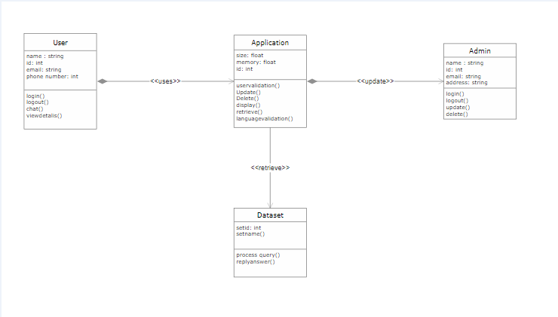

**Communication Protocol Diagram:**

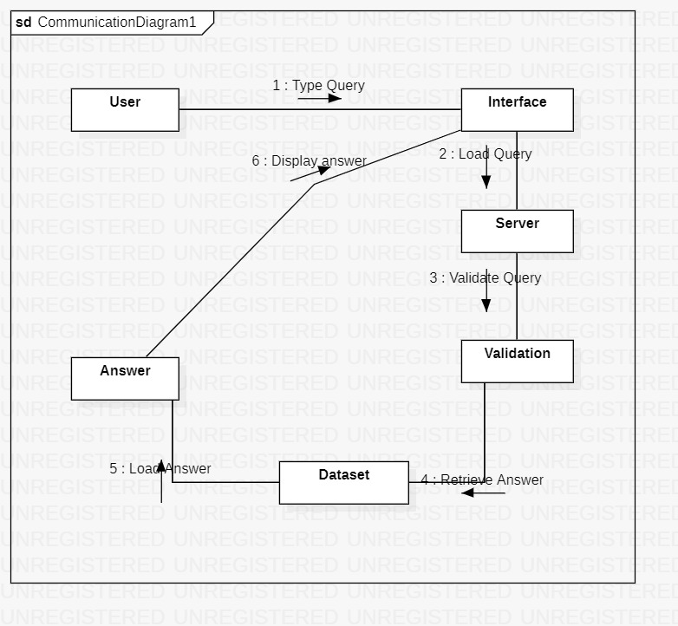

**Deployment Diagram:**

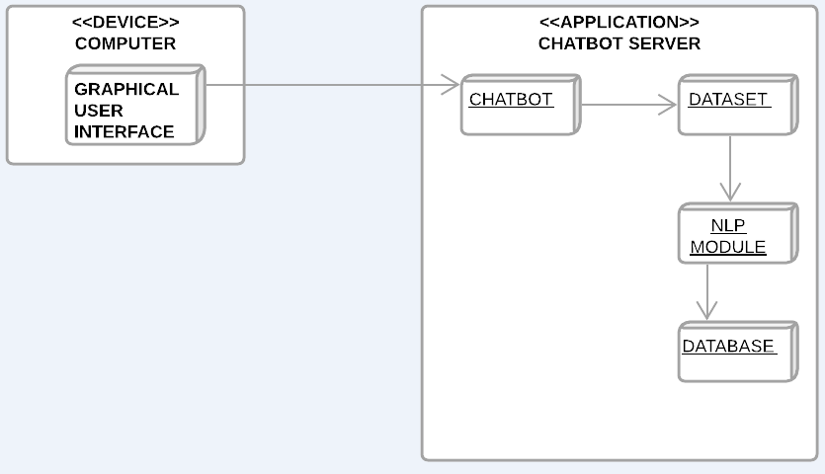

**Package Diagram:**

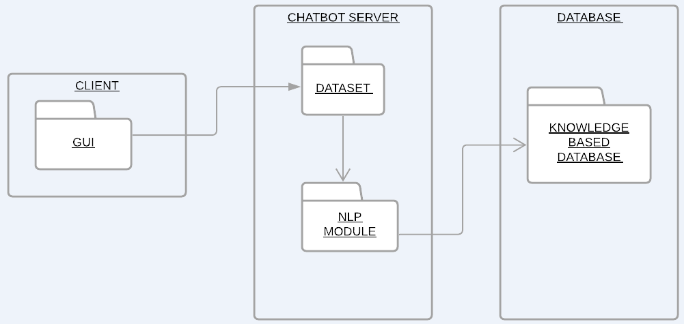

**Component Diagram:**

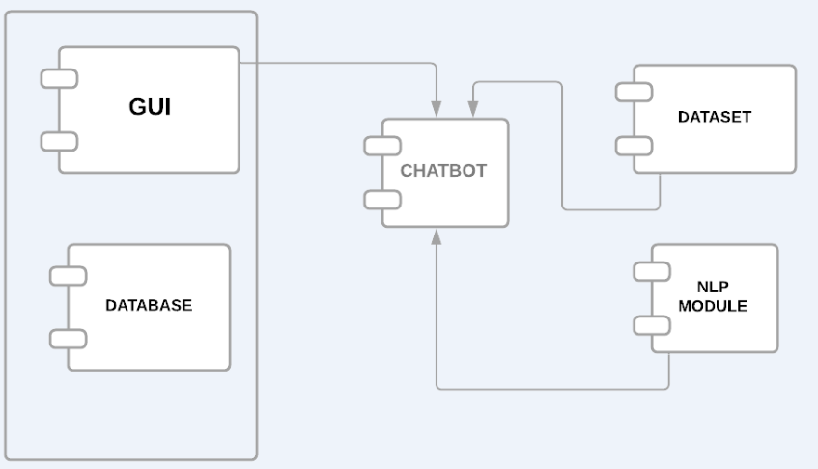

# System Design

**Activity Diagram:**

**QUERY:**

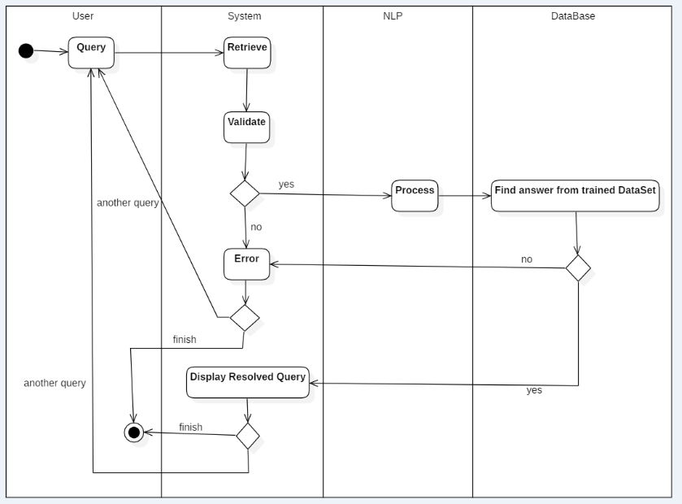

**RESOLVE QUERY:**

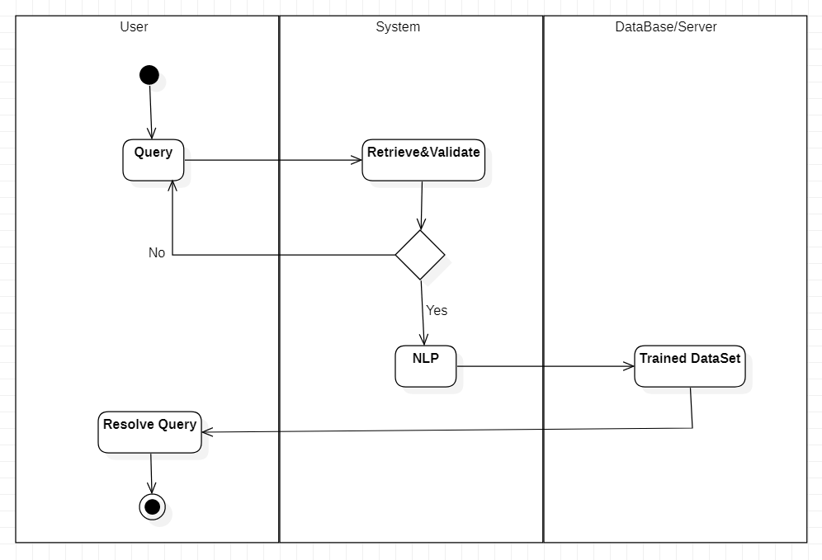

**DELETE DATASET:**

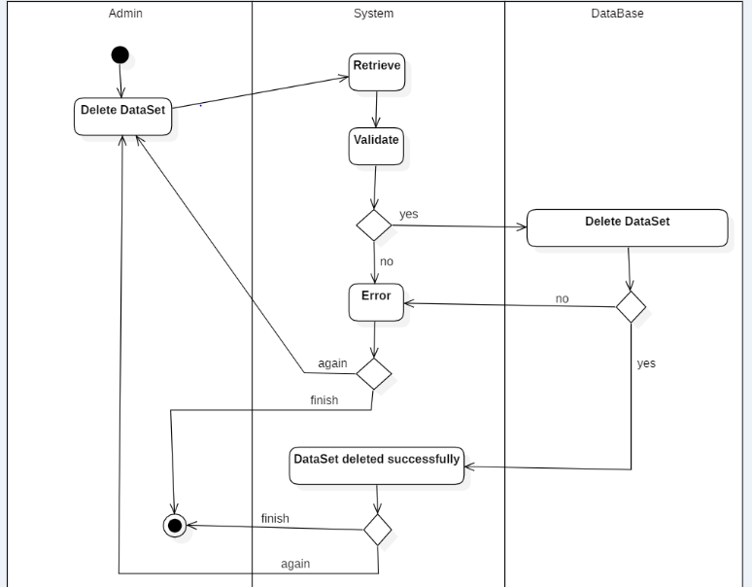

**ADD DATASET:**

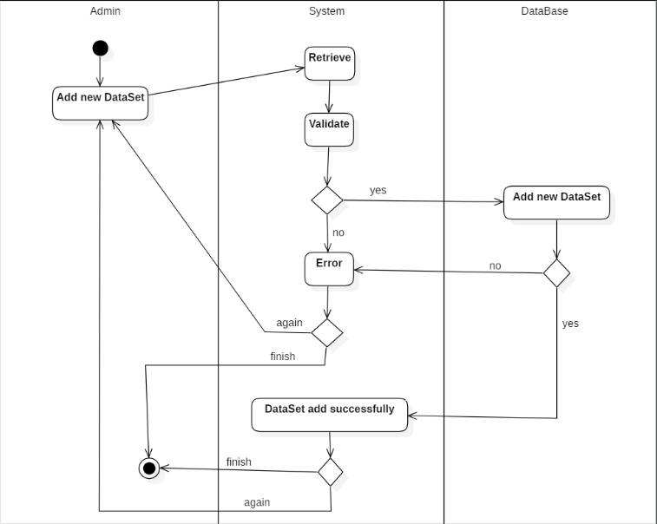

**Sequence Diagram:**

**QUERY:**

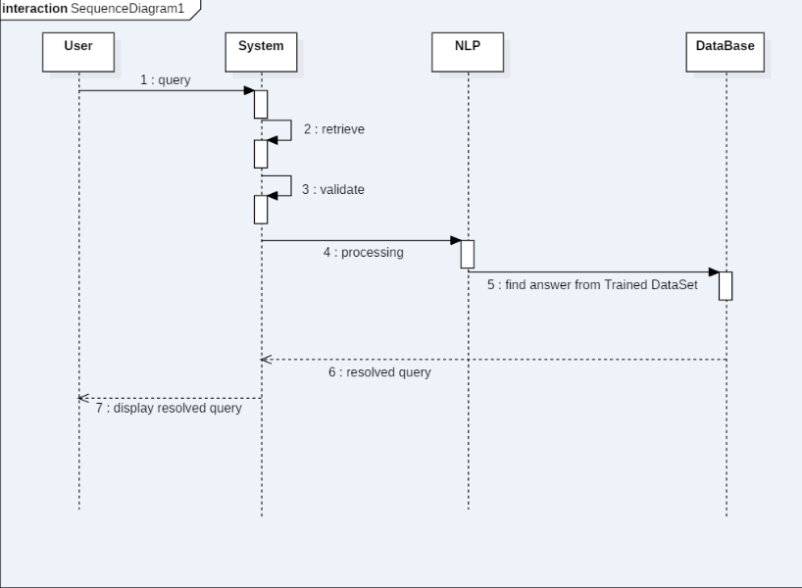

**RESOLVE QUERY:**

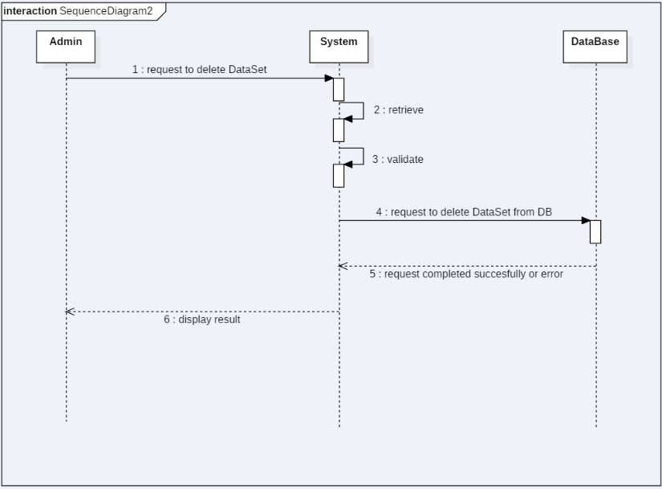

**ADD DATASET:**

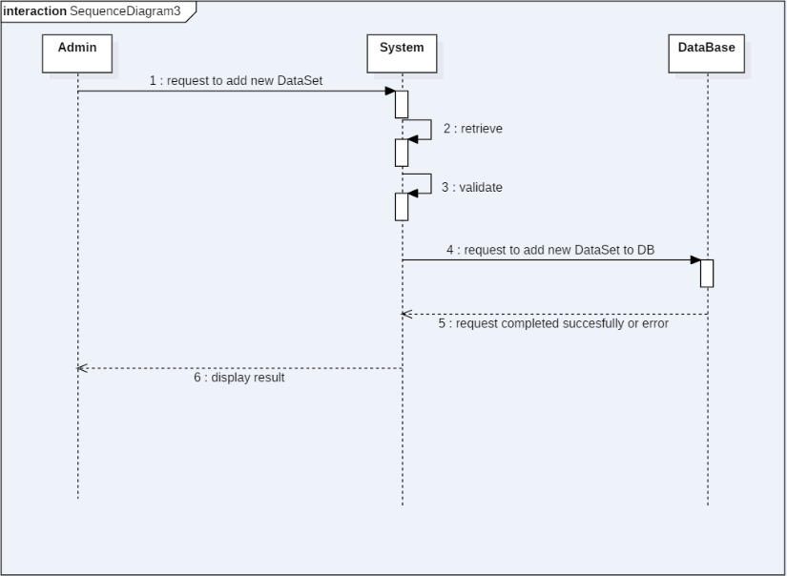

# Chapter 5: Implementation

This chapter will discuss implementation details supported by UML diagrams (if applicable). You will not put your source code here. Any of the following sections may be included based on your project.

# Libraries and Design:

* Speech Recognition: Speech recognition is one of the most important tasks in the domain of human computer interaction. It allows the software to understand the human voice.
* MySQL: It is a database system that runs through web.
* **NLTK** (Natural Language Tool Kit): NLTL is an open-source series of programs and libraries for developing programs in python languages.

NLTK is also referred to as the Natural Language Tool Kit. NLTK offers an easy-to-use interface with diverse corpora and lexical resources, like WordNet, with a series of text processing libraries for tokenization, tagging, semantic reasoning, parsing, stemming, and classification.

* **pyQt5:** PyQt5 is cross-platform GUI toolkit, a set of python bindings for Qt v5. One can develop an interactive desktop application with so much ease because of the tools and simplicity provided by this library.
* **Pyttsx3:** Pyttsx3 is a text-to-speech conversion library in Python. Unlike alternative libraries, it works offline, and is compatible with both Python 2 and 3.
* **ChatterBot:** ChatterBot is a machine-learning based conversational dialog engine build in Python which makes it possible to generate responses based on collections of known conversations. The language independent design of ChatterBot allows it to be trained to speak any language.
* **Threading:** Thread, in this module, nicely encapsulates threads, providing a clean interface to work with them. When you create a Thread, you pass it a function and a list containing the arguments to that function.
* Tkinter: Tkinter is the standard GUI library for Python. Python when combined with Tkinter provides a fast and easy way to create GUI applications.

**Model File:** We have used pytorch library to train new datasets.

**Datasets:** We have tested our chatbot with four different datasets, and they work fine. The datasets used are obtained from Kaggle, GitHub and online websites.

# User Interface

* **SIGNUP MOCKUP:** The user will sign himself up in the database from here.

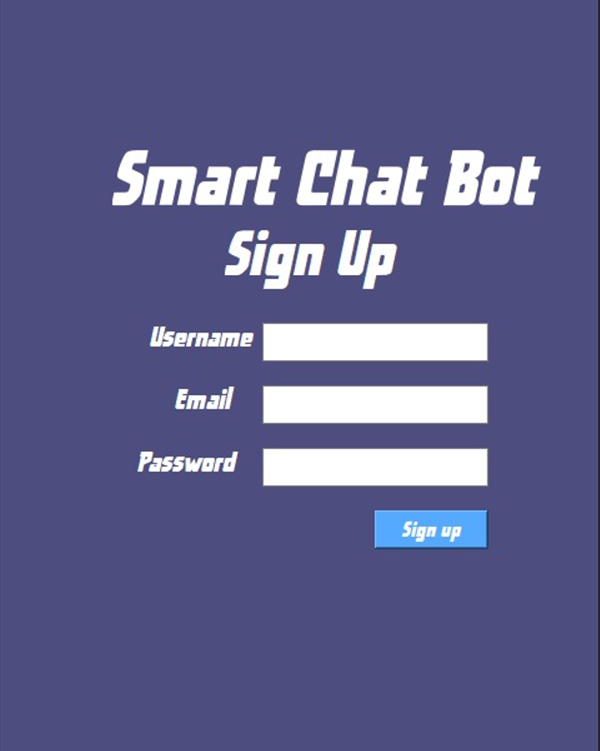

* **LOADING MOCKUP:** The chatbot will load in this mockup.

* **LOGIN MOCKUP:** The user which are already registered can login themselves into the system by using their username and password.

* **ADMIN PANEL MOCKUP:** In the admin panel, the user or admin can upload a dataset from the directory. Here the upload dataset button will take you to browse directory from which you can select any dataset you want to interact with. The delete button will delete the already uploaded dataset, browsed from the directory. The train dataset button will train the selected dataset into the model. The open chat button will take you to the chatbot where the user can interct with the chatbot.

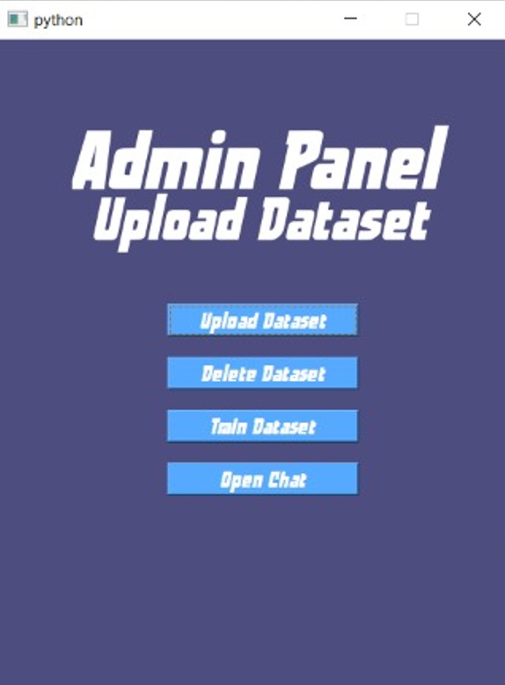

* **DEFAULT HOME-SCREEN MOCKUP:** This chatbot will be where the user will be able to interact with the chatbot. We have given the chatbot a default heme as below, but it can be customized in different colors as required by the user. We also have given the option of selecting different fonts, according to the desires of the user. The screen of the chat can also clear, by selecting the clear screen option. In the help category the user will be briefed about the developers and about the chatbot.

Here are different themes of the chatbot.

**Chapter 6: Testing and Evaluation**

Testing is a process of executing a program or application with the intent of finding the software bugs. It can also be stated as the process of validating and verifying that a software program or application or product: Meets the business and technical requirements that guided its design and development.

# Verification

We are going to develop a system named Smart Chatbot. It will use NLP for language processing. We will train our system with data set to use it with NLP. Smart Chatbot will take input from the user in form of text or speech then process the input using NLP with the trained data set. Our system will process both text and speech given by the user. To make the system user friendly we will use TKinter and Designer for User Interface. We will further use at designer to make our UI attractive.

# Validation

From the customer requirement perspective, the study of design code of different software modules and also from Graphic user interfaces through which the interacts with the system. Test-Case specifications in performed for system testing by keeping in mind several issues, which are discuss in following subtopics.

# Usability Testing

# Module / Unit Testing

Unit testing.

### 

### **Test Case Name: Send Query**

|  |  |  |  |  |  |  |
| --- | --- | --- | --- | --- | --- | --- |
| **Project Name: Deep Leaning Based Chatbot** | | | | | | |
| **Test Case 1** | | | | | | |
| **Test Case ID:** ARID-1466 | | | |  | | |
| **Test Priority (Low/Medium/High):** High | | | | **Test Designed Date :** | | |
| **Module Name:** Send Query | | | |  | | |
| **Test Title:** Test Send Query | | | | **Test Execution Date :** | | |
| **Description** Chatbot will get the query & verify language. | | | |  | | |
| **Pre-Condition:**   * Language should be English * Roman English is not acceptable | | | |  | | |
| **Dependencies:** User must message | | | |  | | |
| **Step** | **Test Steps** | **Test Data** | **Expected Result** | **Actual Result** | **Status**  **(Pass/Fail)** | **Notes** |
| 1- |  |  | After Verification the answer will be generated. | Verification of language has been completed. | Pass |  |

### **Test Case Name: Retrieve Answer**

|  |  |  |  |  |  |  |
| --- | --- | --- | --- | --- | --- | --- |
| **Project Name: Deep Leaning Based Chatbot** | | | | | | |
| **Test Case 2** | | | | | | |
| **Test Case ID:** ARID-1574 | | | |  | | |
| **Test Priority (Low/Medium/High):** High | | | | **Test Designed Date :** | | |
| **Module Name:** Retrieve Answer | | | |  | | |
| **Test Title:** Test Retrieve Answer | | | | **Test Execution Date :** | | |
| **Description** Chatbot will search for query in dataset. | | | |  | | |
| **Pre-Condition:**   * Language should be English * Roman English is not acceptable | | | |  | | |
| **Dependencies:** User must message | | | |  | | |
| **Step** | **Test Steps** | **Test Data** | **Expected Result** | **Actual Result** | **Status**  **(Pass/Fail)** | **Notes** |
| 1- | 2 | Large Data | After searching the query, answer will be generated. | Answer has been generated. | Pass |  |

### **Test Case Name: Display Answer**

|  |  |  |  |  |  |  |
| --- | --- | --- | --- | --- | --- | --- |
| **Project Name: Deep Leaning Based Chatbot** | | | | | | |
| **Test Case 3** | | | | | | |
| **Test Case ID:** ARID-1557 | | | |  | | |
| **Test Priority (Low/Medium/High):** High | | | | **Test Designed Date :** | | |
| **Module Name:** Display Answer | | | |  | | |
| **Test Title:** Test Display Answer | | | | **Test Execution Date :** | | |
| **Description** Chatbot will display answer. | | | |  | | |
| **Pre-Condition:**   * Chatting panel must be open * User must understand English | | | |  | | |
| **Dependencies:** User must message | | | |  | | |
| **Step** | **Test Steps** | **Test Data** | **Expected Result** | **Actual Result** | **Status**  **(Pass/Fail)** | **Notes** |
| 1- |  |  | Message will be displayed on the screen. | Message has been Displayed. | Pass |  |

# Integration Testing

Integration testing.

# System Testing

All the modules will be tested for their properly functionality, to see the efficient working of the whole software.

# Acceptance Testing

Acceptance testing.

# Stress Testing

The software would be tested with large datasets to see if it would be working effectively under large sums of data.

# Hardware Configuration for Testing

The preferred hardware for our system is minimum Core i3 4th generation:

* Processor: 1 gigahertz (GHz) or faster
* RAM: 2 gigabyte GB (64-bit) or more
* Hard disk space: 20 GB (64-bit) or more

# Evaluation

The chatbot would be evaluated to confirm that it’s different modules are working properly and the chatbot is functional.

.

**Chapter 7: Conclusion and Future Work**

This chapter concludes the project and highlights future work.

# Conclusion

Our FYP project is about developing a SMART Chatbot, which would allow the user to interact and ask questions.

Our main focus was to create a chatbot based on deep learning, which would automatically store the data of the datasets and the queries asked by user. Till now we are able to create a self-trained chatbot, which can function well in audio and text input. The user can give audio input as well as text input, to which the chatbot would response effectively. Till now the chatbot is working efficiently. Datasets are being uploaded through which the chatbot would be further trained for full functionality.

# Future Work

Future working requires the chatbot to be trained through various datasets, and Mde efficient enough to load datsets at runtime. We will improve the GUI and make it work with multiple languages. We will strive to make it a universal.

# References

References to any book, journal paper or website should properly be acknowledged. Please consistently follow the style. The following are few examples of different resources i.e. journal article, book, and website.

1 Lyda M.S. Lau, Jayne Curson, Richard Drew, Peter Dew and Christine Leigh, (1999), Use Of VSP Resource Rooms to Support Group Work in a Learning Environment, ACM 99, pp-2. (Journal paper example)

2 Hideyuki Nakanishi, Chikara Yoshida, Toshikazu Nishmora and TuruIshada, (1996), FreeWalk: Supporting Casual Meetings in a Network, pp 308-314 (paper on web) http://www.acm.org/pubs/articles/proceedings/cscw/240080/p308-nakanishi.pdf

3 Ali Behforooz& Frederick J.Hudson, (1996), Software Engineering Fundamentals, Oxford University Press. Chapter 8, pp255-235. (book reference example)

4 Page Author, Page Title, http://www.bt.com/bttj/archive.htm, Last date accessed. (web site)